Hong Kong Exchanges and Clearing Limited and The Stock Exchange of Hong Kong Limited take no responsibility for the contents of this announcement, make no representation as to its accuracy or completeness and expressly disclaim any liability whatsoever for any loss howsoever arising from or in reliance upon the whole or any part of the contents of this announcement.

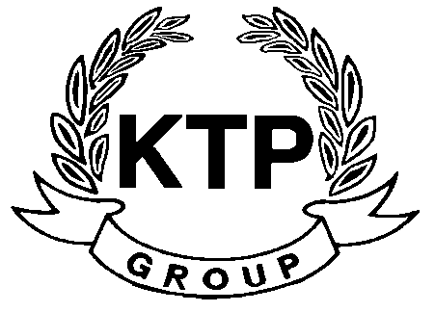
KTP HOLDINGS LIMITED
港台集團有限公司*
(Incorporated in Bermuda with limited liability)
(Stock code: 645)

NOTICE OF BOARD MEETING

The board of directors (the “Board”) of KTP Holdings Limited (the “Company”) hereby announces that a meeting of the Board will be held at 43/F, The Lee Gardens, 33 Hysan Avenue, Causeway Bay, Hong Kong at 10:00 a.m. on Tuesday, 28th June 2011 for the purpose of considering and approving the final results of the Company and its subsidiaries for the year ended 31st March 2011 and considering the recommendation of a final dividend, if any.

By Order of the Board
KTP Holdings Limited
Chua Chun Kay
Chairman
Hong Kong, 16th June 2011

As at the date of this announcement, the executive director of the Company is Mr. Chua Chun Kay (Chairman) and the independent non-executive directors are Mr. Yeung Kin Bond, Sydney, Mr. Lam Pun Yuen, Frank and Mr. Ngan Hing Hon.

*For identification purpose only

